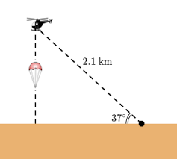**Unit 7 Trigonometry Task**

**Goal:**

The goal of this task is to write your own Trigonometry word problem using historically accurate and mathematically accurate contexts.

**Product:**

*****You must have 3 components:*

* Write the context of the problem in a few complete sentences. Historical context should include WHO, WHAT, WHEN, and WHERE. You may use real or fictional people, as long as the details are historically accurate.
* Write the mathematical set up of the problem. The mathematical vocabulary in the problem must lead the person reading it to draw a right triangle to solve for either an angle or a side. The numbers and units can be made up but they should be realistic.
* Draw the diagram for the problem and solve it using trigonometry. The last step is to write a sentence putting your answer back in the context of the problem (including units!)

This can be neatly handwritten or typed.

**GOOD LUCK!**

 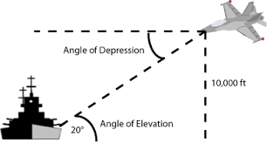 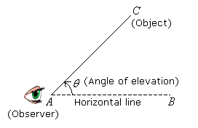

**Unit 7 Trigonometry Task Rubric**

|  |  |  |  |  |
| --- | --- | --- | --- | --- |
|  | **4** | **3** | **2** | **1** |
| **Creativity and Historical Context**  Creation of problem is unique and historically accurate | Problem is creative, in complete sentences, and completely historically accurate. | Problem is in complete sentences but may not be completely historically accurate. | Problem is not in complete sentences and is not historically accurate. | Work is missing or plagiarized. |
| **Modeling**  Set up of problem uses precise mathematical language and diagram to model | Diagram is drawn neatly, accurately, and used with precise mathematical language. | Diagram is set up but problem does not contain precise mathematical language. | Diagram is not set up and problem does not contain precise mathematical language. | Work is missing or plagiarized. |
| **Calculation**    Mathematical calculations are accurate and put back into context | Calculations are completely accurate and units are used to put the answer back into the historical context | Calculations are mostly accurate and units are used to put the answer back into the historical context | Calculations are not accurate and the answer has not been put back into the historical context | Work is missing or plagiarized. |

**Rubric Score: _________ / 12 Converted Score: __________ / 100**